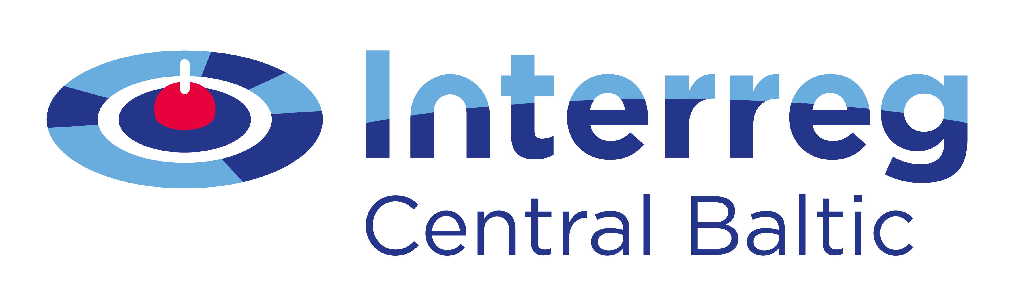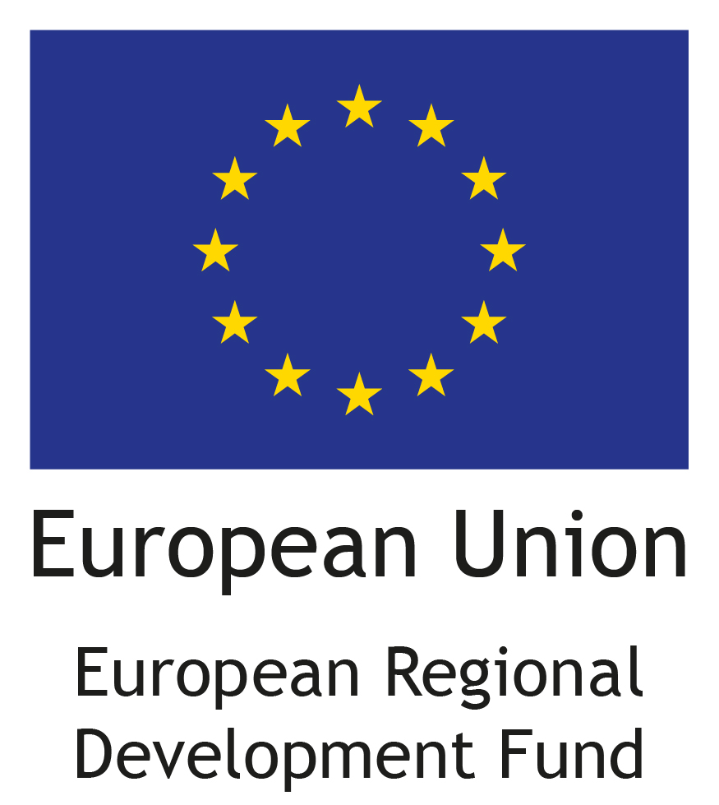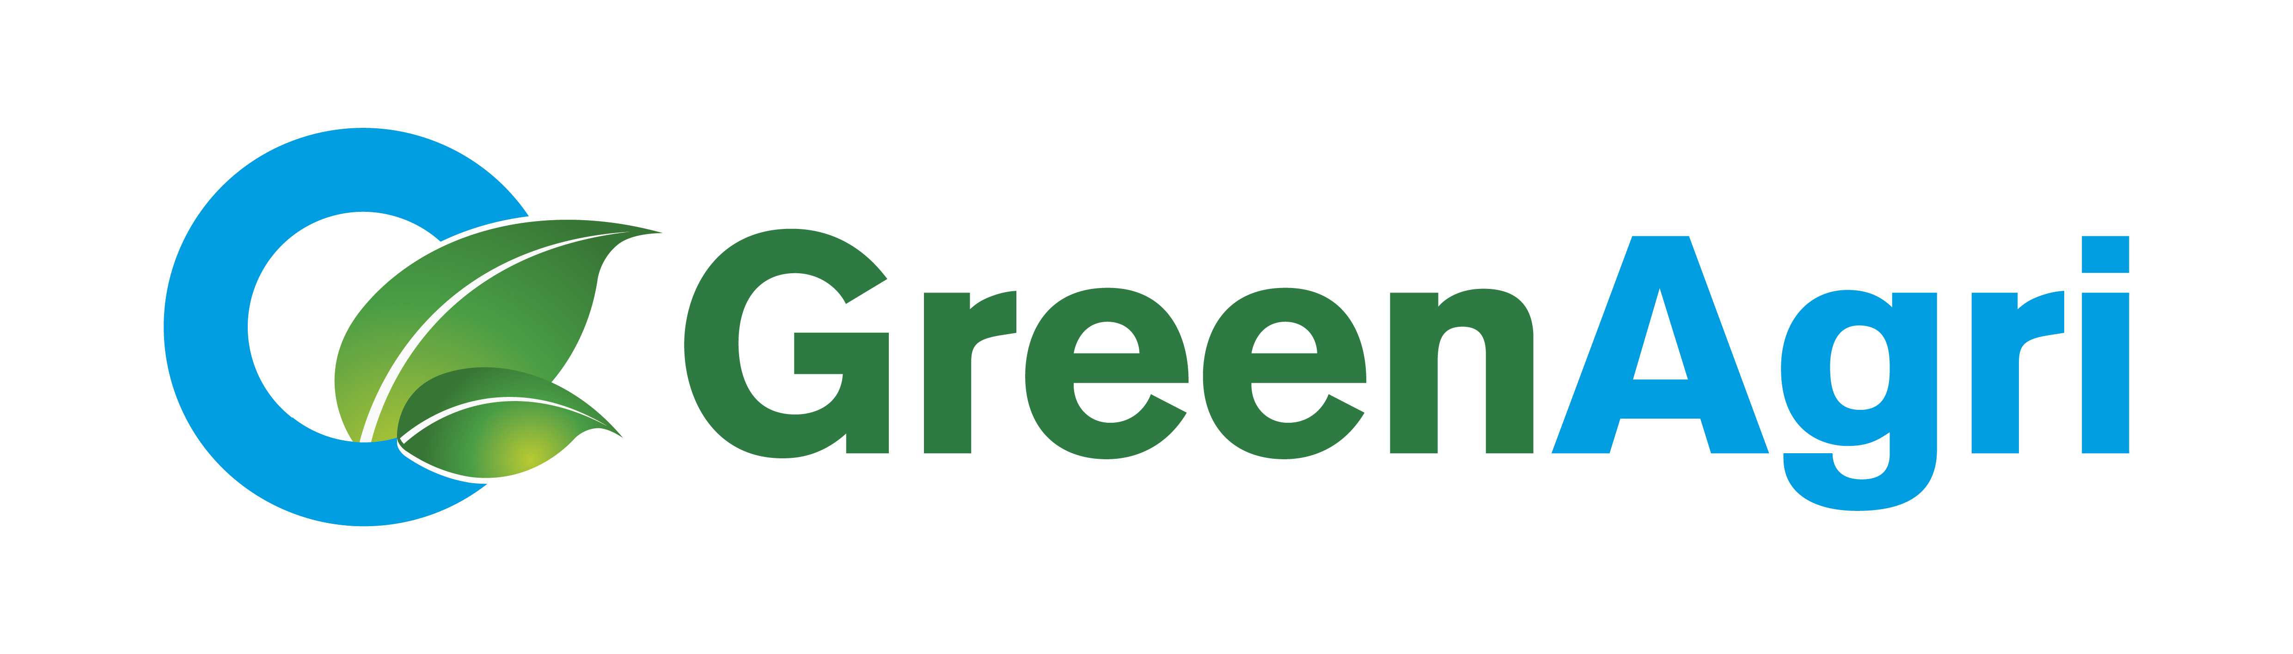

Seminar for agricultural advisors and enviromental experts

Program

15-16st November, 2016
Hotel “Dorpat” seminar room “Krause”, Tartu, Estonia

Tuesday, 15.11.2016. hotel “Dorpat”, seminar room “Krause”
12:00-13:00 | Lunch, hotel “Dorpat”, Tartu
13:00 – 14:30 | New EU-legislation affects use of nitrogen in agriculture – Ivan Brendstrup, Farmer Focus Manager, BASF
14:30 – 15:00 | Coffee break
15:00 – 16:30 | Danish legislation and use of N-inhibitores in Agriculture - Ivan Brendstrup, Farmer Focus Manager, BASF
16:30-17:00 | Discussion

Wendsday, 16.11.2016 hotel “Dorpat”, seminar room “Krause”
9:00 – 11:15 | Role of soil biota in arable ecosystem – Merrit Shankiy, Estonian University of Life Sciences
11:15 – 11:45 | Coffee break
11:45 – 12:30 | Greenhouse gas emissions from agricultural fields – Jordi Escuer, Estonian University of Life Sciences
12:30 – 13:30 | Lunch, hotel “Dorpat”
13:30 – 15:00 | Does humus exists? Importance of soil organic matter – Alar Astover, Estonian University of Life Sciences
15:00 – 15:15 | Coffee break
15:15 – 16:30 | Nitrogen cycling in agricultural soil – from basic processes to applied examples – Alar Astover, Estonian University of Life Sciences

Seminar is organized in the framework of project “GreenAgri”CB272 and partly financed by the Central-Baltic Programme 2014-2020 and Union “Farmers Parliament”.

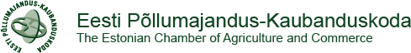 | 

